Qasim Amin (1863-1908)
قاسم أمين

[Summary]
Born in Alexandria in 1863, Qasim Amin was a significant figure in the intellectual and political circles of late-nineteenth and early twentieth-century Egypt. He is most famous for his treatment of the 'woman question', the debate over the place of women in society that took place amongst nationalists and Islamic religious modernisers during this period. Amin's writings on women have earned him the title in some quarters of the 'first feminist' in the Arab world, but critics have seen him instead as a promoter of colonial values and of a narrow, elite perspective stemming from his aristocratic origins and Westernised education and career.

[Main text]
Qasim Amin was born to an aristocratic Ottoman family; his father was a governor in Kurdistan before moving to Egypt as a senior officer in Khedive Isma'il's army, and his mother was related to the Egyptian ruling family. As such, Amin, the possessor of a hereditary title, was firmly entrenched in the land-owning elite. This privileged position was consolidated by education at prestigious schools, followed by a government scholarship at the Université de Montpellier and marriage to a woman who also came from the Egyptian aristocracy.

Amin rapidly became a successful member of the British-controlled colonial administration's civil service, starting in the Mixed Courts (which combined Islamic and Napoleonic judicial influences), moving to the Government Division of Legal Affairs, and then becoming a judge in the National Court. Each of these roles involved him working alongside staff of British and other European origins.

In tandem with this position in the colonial system, however, Amin was also very much a part of the Egyptian national movement. During his teens he had frequented coffee houses where figures such as Saad Zaghlul and Adib Ishaq, influenced by al-Afghani, talked politics in the run-up to Urabi Pasha's attempted revolution. Amin was also inspired by the ideas of Muhammad Abduh, for whom he worked as a translator in France; during this time Amin joined Abduh and al-Afghani in editing al-Urwa al-wuthqa (The Strongest Bond), an Arabic newspaper which called for Islamic reform and unity against European colonial powers. Later, Amin was one of the founding members of the National University (later Cairo University). All of these figures were part of what is often known as the Nahda, or Arabic Enlightenment, although such a term is sometimes seen as Eurocentric. But, they all belonged to a period of intellectual ferment in which those such as Abduh argued that the Islamic world had declined morally and culturally, making it vulnerable to European colonialism and demanding a return to a truer, purer faith.

Qasim Amin's first major foray into public writing was his rebuttal of the Duc d'Harcourt's 1893 attack on Egyptian society and culture. In Les Egyptiens: response a M. Le duc d'Harcourt (The Egyptians: a Response to M. the Duc d'Harcourt, 1894), Amin issued a defence of both Islam and the place of women in Egypt's culture and society. But, by 1899 his position had shifted, influenced, according to varying accounts, by Abduh or by the literary hostess Princess Nazli. In Tahrir al-Marʾāh (The Liberation of Women), Amin instead followed an Islamic reformist line, arguing that the accretion of external customs onto the original body of Islam had caused the oppression of women. He characterised Egyptian women as idle, uneducated, kept in a state of isolation and ignorance by their fathers and husbands. Their relationships with their husbands and families were, he said, unhealthily manipulative, and their interests shallow, divorced from the public sphere. This, claimed Amin, was ruinous not just for the women themselves but for the nation as a whole; such women, he asserted, could not raise educated, capable children, and thus Egyptian society was deprived of the strength it needed to function in the modern world.

The Liberation of Women is the book that made Qasim Amin's reputation. It became instantly controversial on its publication in 1899, attracting excoriating reviews from some and enthusiastic welcomes from others. Amin's second book on the subject, al-Marʾāh al-jadidah (The New Woman), followed a year later, responding to criticisms of The Liberation of Women by adding more liberal, Westernised arguments to the earlier book's reliance on ideas from the Islamic reformers like Abduh. Both books draw on Arabic and European intellectual traditions; as well as religious references, Charles Darwin and John Stuart Mill are often mentioned as influences.

The conventional view of Qasim Amin and his writings on women is that they make him the 'first Arab feminist', a founder of the notion of women's liberation within Islam. In this role he has appeared on Egyptian postage stamps, been hailed as a hero in books and blogs, and claimed as their own by various political strands within Egypt. Dissenting voices have, however, been raised by scholars such as Leila Ahmed and Lila Abu-Lughod. Some argue that Amin's elite position gave him a narrow and inaccurate view of the lives of Egyptian women (and men). The cosseted, isolated existences he described could only, by definition, be afforded by the rich. Amongst the urban and rural poor, women worked and had no option but to come and go in the public sphere. Indeed, scholars such as Beth Baron and Marilyn Booth argue that Qasim Amin only attracted so much attention precisely because he was a man, and Egyptian women writers had argued similar points before and concurrently with the publication of The Liberation of Women and The New Woman. Titles such as 'the first Arab feminist' and 'the father of Egyptian feminism' obscure potentially obscure, therefore the significant role that women writers and women's publications had to play in changing gender norms

Leila Ahmed has argued strongly that Amin's views of Egyptian culture and religion came not from an internal, indigenous critique but from European colonial influences. Ahmed suggests, for instance, that Amin's focus on the veil as a means of secluding Egyptian women is typical of European, rather than Egyptian women's, concerns, whilst Lila Abu-Lughod points to his uncritical praise for the nuclear family, also a potential site of women's oppression. A closer reading of Amin's writing, Abu-Lughod has suggested, shows that he was not a 'feminist' in the sense of being motivated by support for women themselves. With his social Darwinist ideas about 'backward' and 'developed' societies, Amin was using the position of women as a marker for his notion of progress in Egyptian society.

Qasim Amin: Complete Works (various editions, most respected at the moment seems to be ed. M. Imarah, Dar al-Shorouq, 2008)

Les Egyptiens: reponse a M. le duc D'Harcourt (The Egyptians: a response to M. the Duc d'Harcourt) Cairo: Jules Barbier, 1894 (French)
تحرير المرأة Tahrir al-Marʾāh (The liberation of woman) 1899 (Arabic)
المرأة الجديدة al-Marʾāh al-jadidah (The new woman) 1900 (Arabic)

كلمات Kalimāt (Aphorisms) Cairo: Maṭbaʻat al-Jarīdah, 1908
اسباب ونتائج and اخلاق ومواعظ (Asbāb wa-natāʼij and akhlāq wa-mawāʻiẓ) Causes and effects and Morals and exhortations: excerpts from the journal al-Mu'ayyad. Alexandria, Maṭbaʻat Jirjī ʻArzūzī, 1913

[English edition] The Liberation of Women and The New Woman: Two Documents in the History of Egyptian Feminism
Translated by Samiha Sidhom Peterson
Cairo: American University of Cairo Press, 2000

Further reading:
Abu-Lughod, Lila (ed), Remaking Women: Feminism and Modernity in the Middle East: Feminism and Modernity in the Middle East. Princeton University Press, 1998
Ahmed, Leila, Women and Gender in Islam: Historical Roots of the Modern Debate. New Haven and London: Yale University Press, 1992
Baron, Beth, The Women's Awakening in Egypt: Culture, Society and the Press. New Haven: Yale University Press, 1994
Booth, Marilyn and Gorman, Anthony (eds), The Long 1890s in Egypt: Colonial Quiescence, Subterranean Resistance. Edinburgh: Edinburgh University Press, 2014
Hourani, Albert, Arabic Thought in the Liberal Age. Cambridge: Cambridge University Press, 1983

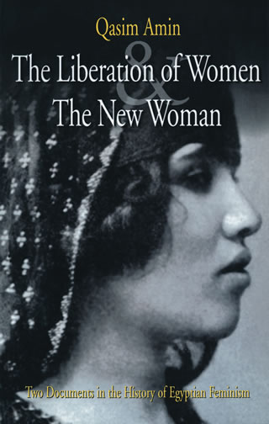
Cover of the current English edition of Tahrir al-Mar'ah and al-Mar'ah al-jadidah
http://www.aucpress.com/images/Product/large/4245671.jpg
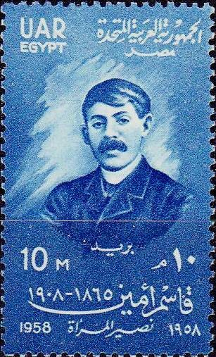
1958 Egypt-United Arab Republic stamp on 50th anniversary of Qasim Amin's death
http://colnect.com/en/stamps/stamp/180420-Qasim_Amin-50th_Death_Anniversary_of_Qasim_Amin-Egypt

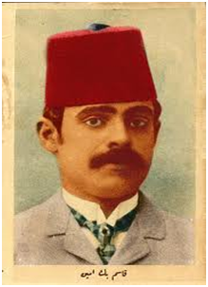
Postcard of Qasim Amin, n.d
http://www.orientalistica.it/?attachment_id=183
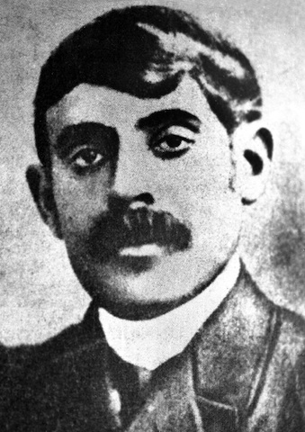
The classic image of Qasim Amin, found throughout the internet
http://www.lesclesdumoyenorient.com/Qasim-Amin-un-penseur-feministe.html (same image also http://en.wikipedia.org/wiki/Qasim_Amin and http://www.copts-united.com/Article.php?I=599&A=20113 etc)

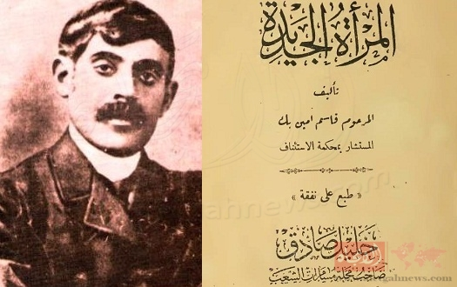
Image of Amin with cover of the first edition of al-Mar'ah al-jadidah
http://mail.aletgahnews.com/news/View/43873/%D9%84%D9%84%D8%AA%D8%A7%D8%B1%D9%8A%D8%AE+%D9%88%D8%A8%D8%A7%D9%84%D8%B5%D9%88%D8%B1+..+%D8%A7%D9%84%D9%86%D8%B5+%D8%A7%D9%84%D8%A3%D8%B5%D9%84%D9%8A+%D9%84%D9%85%D9%82%D8%AF%D9%85%D8%A9+%D8%A2%D8%AE%D8%B1+%D9%83%D8%AA%D8%A7%D8%A8+%D8%A3%D9%84%D9%91%D9%81%D9%87+%D9%82%D8%A7%D8%B3%D9%85+%D8%A3%D9%85%D9%8A%D9%86/#.VWnL8FKzm1k
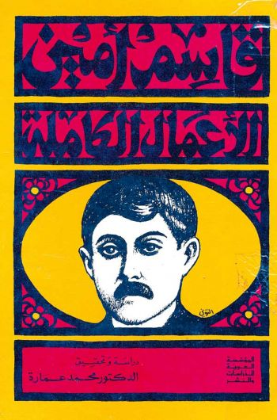
Cover of a modern edition of Complete Works
http://www.ahm1.com/nu/news-action-show-id-324.htm

